 |  |  | 
 |  | 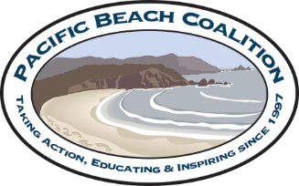 | 
 | 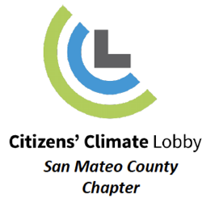 |  | 
 |  |  | 
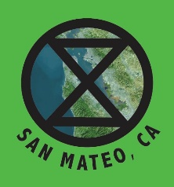

Honorable San Mateo County Board of Supervisors
400 County Center
Redwood City, CA 94063

RE: Support for SMC Divestment

July 12, 2021

Dear County Supervisors

San Mateo County is already experiencing the impacts of climate change, through rising sea levels, coastal erosion, drought, and increased wildfires which are negatively affecting human wellbeing and the environment. Climate change disproportionately impacts communities of color and low income communities due to inequity of power and lack of access to means and resources for prevention and relief.
The International Panel on Climate Change concluded in 2018 that we have 12 years to make dramatic cuts in the use of fossil fuels (coal, oil, gas and tar sands) if we are to keep warming to 1.5º C and avoid more catastrophic changes.
State Treasurer and ex officio CalPERS Board Member Fiona Ma stated that, “Where we invest our money reflects our values, and we should be valuing a clean energy future for California.”
We call on the San Mateo County Board of Supervisors to pass a resolution calling for divesting the San Mateo county investment pool from fossil fuels by making no new or renewed investments in fossil fuel corporations. If the county divests, it will be joining over 1,300 institutions worldwide with 14 trillion dollars in assets that have already divested, including the Sonoma County investment pool, State of New York Retirement Funds, the Vatican, United Church of Christ, Episcopal Church USA, Unitarian Church, World Council of Churches, San Francisco State University, De Anza Foothill Community College District, Stanford University, University of California, and the Bay Area Cities of Brisbane, Mountain View, Palo Alto, San Francisco, San Jose, Pacifica, Sunnyvale, and Richmond.

Sincerely,

Organizational Endorsements

Pacifica Climate Committee
Acterra
Pacificans for Highway 1 Alternatives
Pacificans for a Scenic Coast
Silicon Valley Youth Climate Action
Citizens’ Climate Lobby - San Mateo County
Citizens’ Climate Lobby - San Mateo County Chapter Youth Group
Peninsula Solidarity Cohort
Fossil Free Mid-Peninsula
Pacific Beach Coalition
Social Action Committee, Unitarian Universalist Fellowship of Redwood City
Pacifica Peace People
Sustainable Silicon Valley
Unitarian Universalists of San Mateo
Pacifica Progressive Alliance
Silicon Valley Bicycle Coalition
Menlo Spark
Menlo Together
Extinction Rebellion, San Mateo County

Individual Endorsements
Mark Hubbell, Pacifica CA
James Fithian, Pacifica
Carolyn Jaramillo, Pacifica, CA
Peter Loeb, Pacifica, CA
Ellen Hage, Pacifica, CA
Suzanne Moore, Pacifica, CA
Marj Davis, Pacifica, CA
Tom Kabat, Menlo Park, CA
Yasmin Yazdi, Belmont, CA
Leane Eberhart, Architect San Mateo, CA
Lauren Weston, Executive Director, Acterra: Action for a Healthy Planet
Nicholas Carter, PhD, Founder & Owner, npc Solar, San Carlos, CA
Jennifer Thompson, Executive Director, Sustainable Silicon Valley
Kathleen Goforth, San Carlos, CA
André Goforth, San Carlos, CA
Mark Bauhaus, San Carlos CA
Conan and Lori Low, San Carlos, CA
Natasha and Shawn Melley, San Carlos, CA
Darshana Maya Greenfield, Menlo Park CA
Cynthia Kaufman, Pacifica, PCC, PPA
Elaine Salinger, VMD, San Mateo Highlands
Debbie Denton, San Carlos, CA
David Brittain, San Carlos, CA
Deborah Hernas, San Carlos, CA
Sundance Banks, San Mateo, CA
Carolyn Shepard, Belmont, CA
Carol Cross, Redwood City, CA
Andrew Pattarelli, Menlo Park, CA
Celine Gerakin, Fort Bragg, CA
Kristy Phillips and Ron Piovesan, San Carlos, CA
Lynn Adams, Pacifica, CA
Robert Whitehair, San Mateo
Kathie Muhler, Pacifica, CA
Delia McGrath, Pacifica, CA
Deirdre Martin, Pacifica, CA
Christine Kohl-Zaugg, Executive Director, Sustainable San Mateo County
Rev. Ben Meyers, Unitarian Universalist Minister, San Mateo, CA
Bruce Naegel, Mountain View CA
Celeste Langille, Pacifica, PCC
Karen Grove, Menlo Park, CA
Alice Kaufman, Redwood City, CA
Carlos Davidson, Pacifica, CA
Jared Johnson, Policy Fellow Acterra: Action for a Healthy Planet
Diane Bailey, Executive Director, Menlo Spark
Gary H. White, Founder/Leader, Extinction Rebellion San Mateo
David Elliston, Belmont, CA

